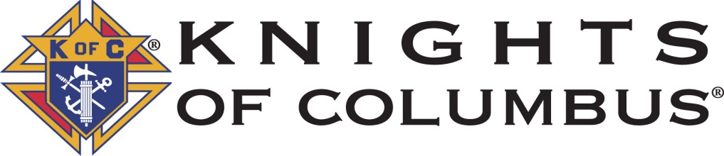
Council 9349 Charity Scramble Golf Tournament
May 11, 2024@ Applewood Golf Course
Check-in at 12:30-1:20pm, Shotgun start at 1:30pm

You can register as a single or a foursome. Format will be a four-person scramble. We will use the Modified Peoria System for handicapping. The Rules and contest holes will be handed out the day of the tournament. Cost is $100/golfer, this includes green fee, cart, range balls, prizes, and a hot lunch after the tournament (please include $20 for any non-golfer attending the luncheon). Mulligans available for a donation of $5 per mulligan, limit two mulligans per golfer. Also, 3 foot of string is available for a donation of $10 per foursome (limit one per foursome).
Proceeds to support Chalices for newly ordained Priests and Other charities supported by the Knights of Columbus
----------------------------------------------------------------------------------------------------------------------
Registration Form (please enclose with check made out to KofC Council 9349)
Name(s) | Phone Number | e-mail
Number of Golfers @ $100: ______ Non-golf Banquet Guests @$20: ______
Total Check Enclosed: $____________
RSVP by phone or email to John Barder at 303-981-4878, Barderjohn84@gmail.com. Please mail checks no later than May 4, 2024, to: John Barder, 8222 West Nichols Ave., Littleton, CO 80128.

